1.also access account and contact records as well.
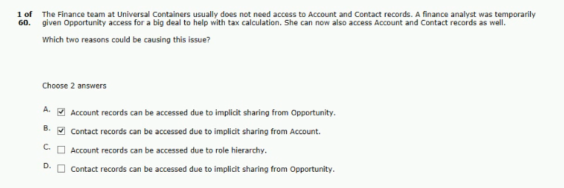
2.the architect has been asked to help troubleshoot.
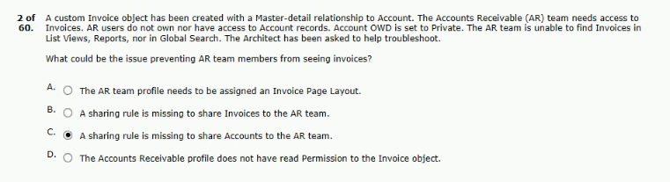
3.setting for the custom delivery object is private.
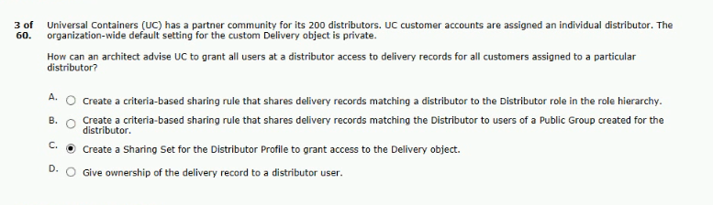

4.employes should also be able to see leads.
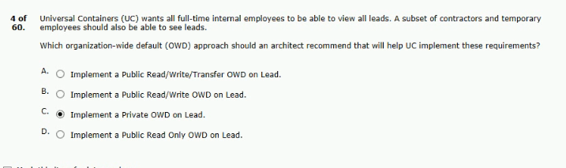
5.to reorganize the roles and reassign accounts owners.
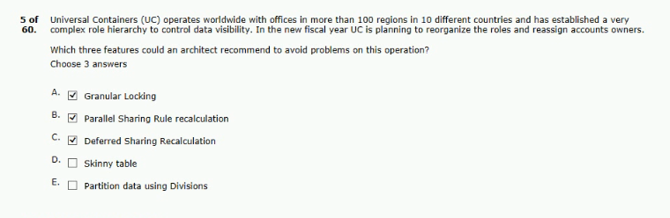
6.a dynamic SOQL query returning the results to the users.
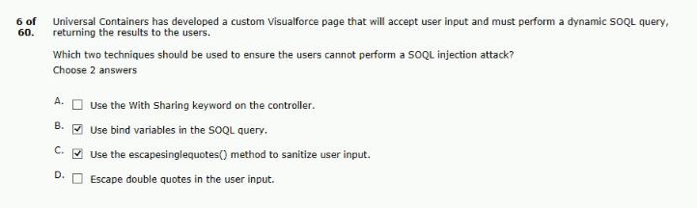

7.assessor is a lookup field on the case object.
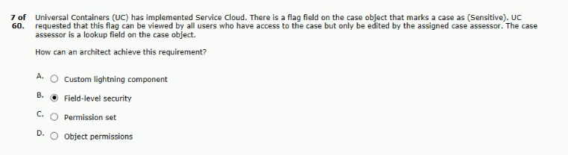
8.other than the owner and the strategic team
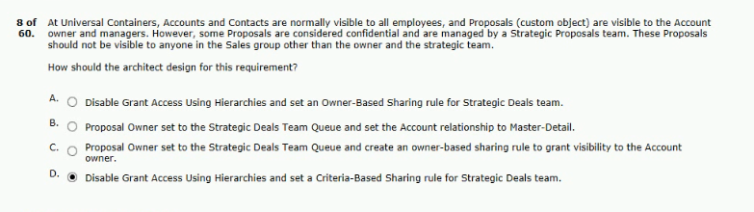
9.salesforce using external objects and did the following.
between account and the invoice.
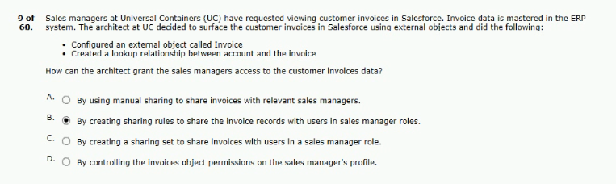

10.only edited/reassigned by the lead owner.
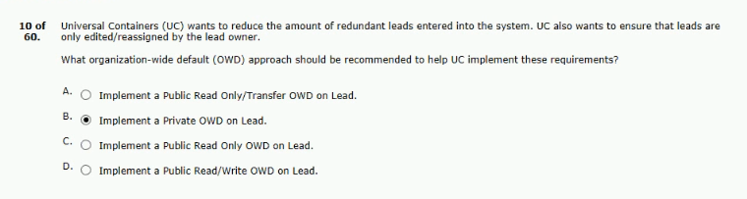
11.are not present within the salesforce organization.
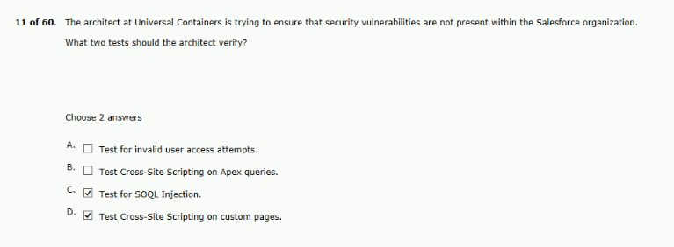
12.salary grade level last performance rating.
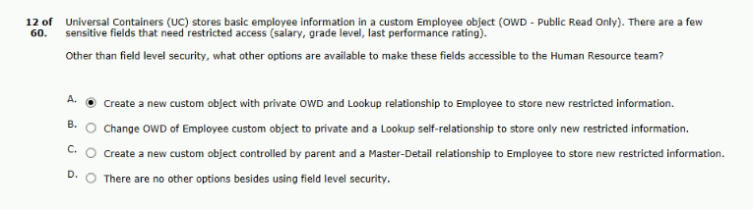

13.sales rep is added to that opportunity team.
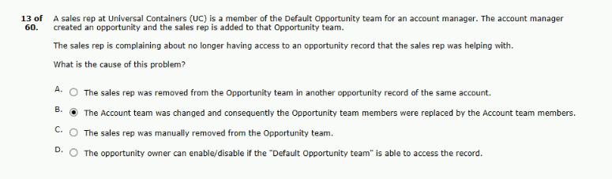
14.and cloud not find the share button.
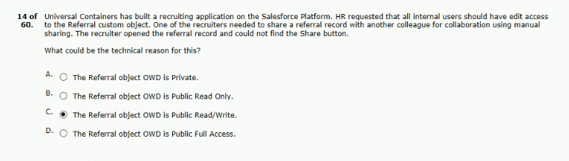
15.australia to assist them with closing their deals.
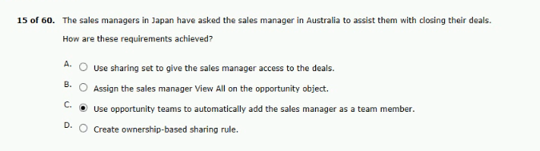

16.for a record of an object which OWD is private.
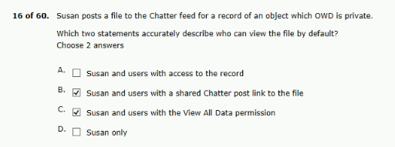
17.sales team with the following structure.
sales opportunities according to the above structure.
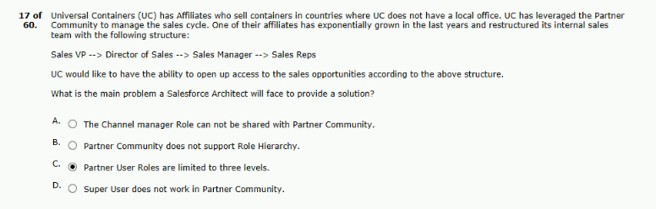
18.to all accounts of the same segment in other countries.
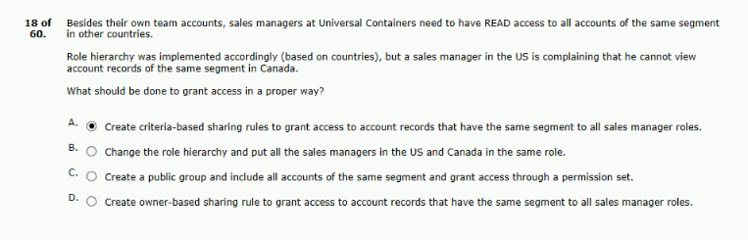

19.team should not have access to shipment records.
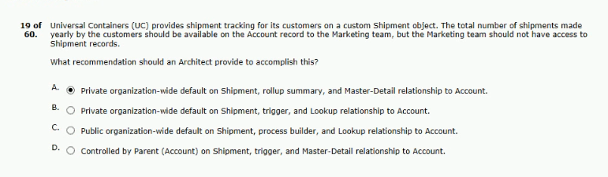
20.reps ended up growing over 50,000 donors each.
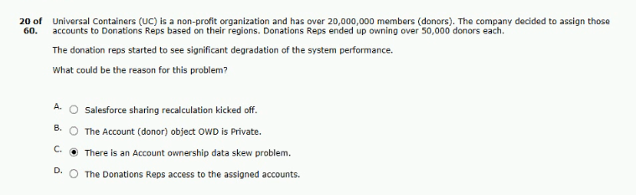
21.that need short-term access to the community.
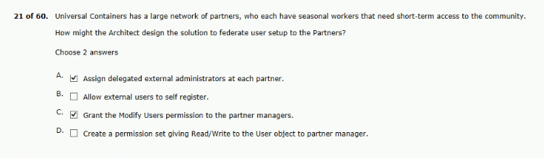

22.by UC users in the customer support role.
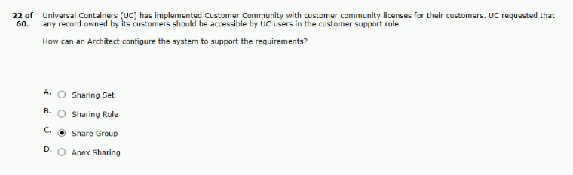
23.and grant access to the new assistant.
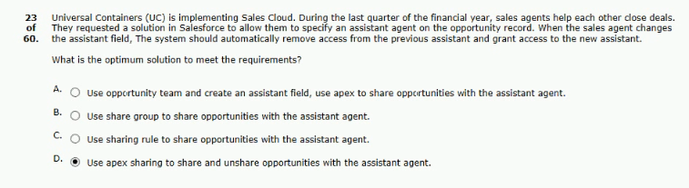
24. territory management territories (portugal and southern europe)
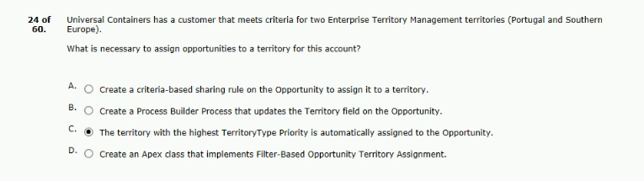
Ans - D (record)

25.which two objects support creating queues?
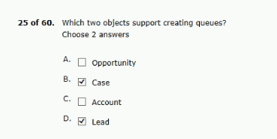
26.still have a access to the invoice object.
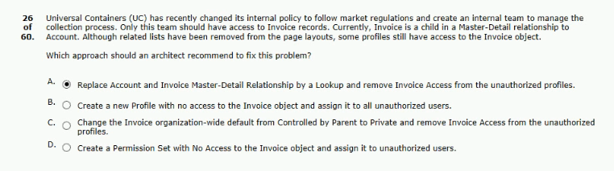
27.error messages appearing when closing an opportunity.
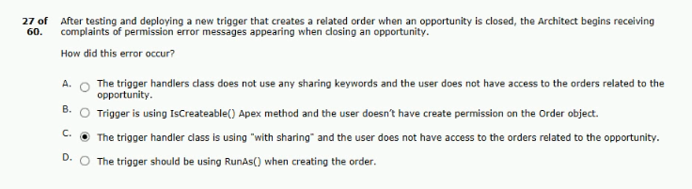

28.to a senior account manager in the near future.
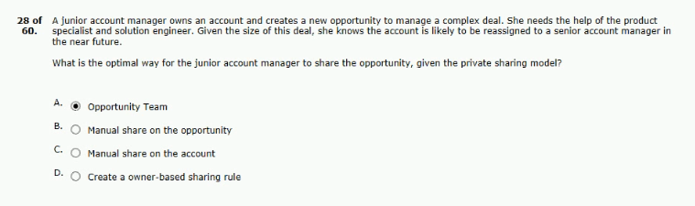
29.audit user setup in the salesforce org.
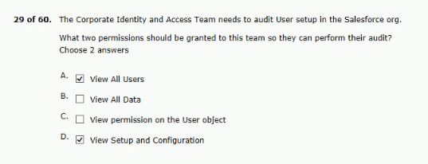
30.by other agents of the same distributor.
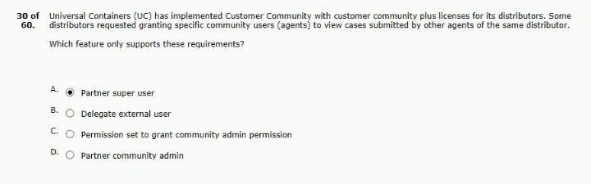

31.in case object (private OWD).
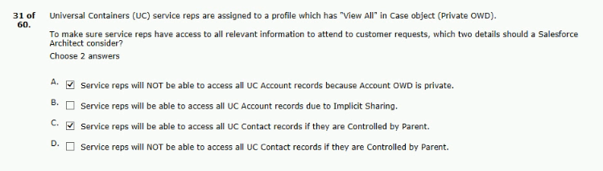
32.promote score (NPS) for all of its employees.
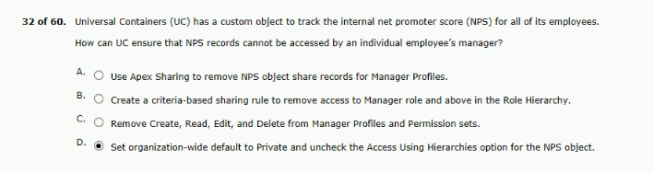
33.rather than static queries and bind variables?
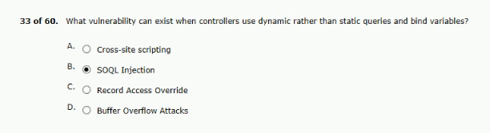

34.but have access to ALL retail customers.
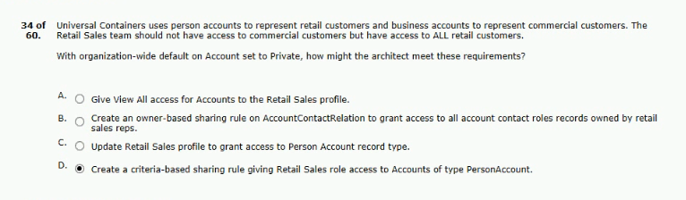
35.has create/edit access to opportunity records.
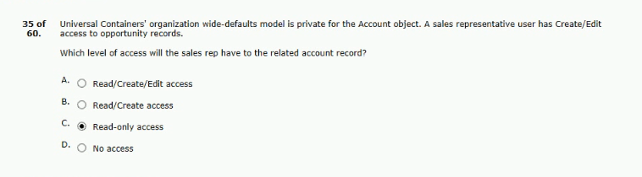
36.views to filter opportunities for certain geographies.
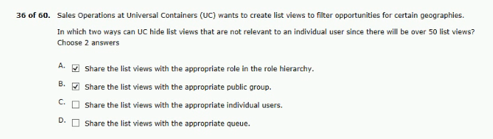

37.license type must the user be given?
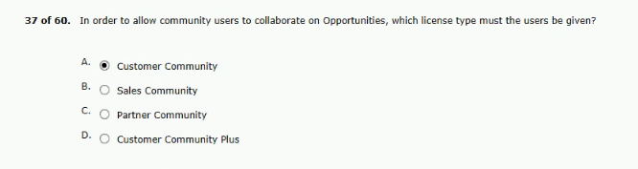
38.assiociated should only get the following permission:
how can an architect achieve these requirements?
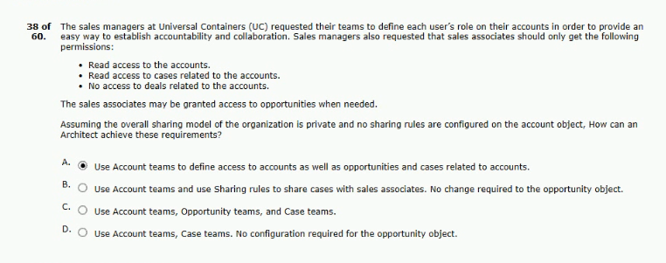
39.cannot be changed by a sales representative.
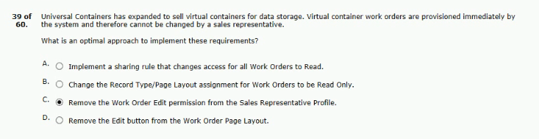

40.the roles and reassign accounts owners.
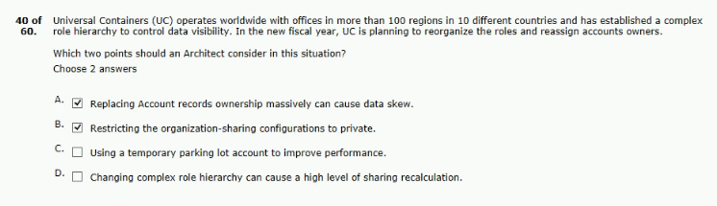
41.seeing chatter posts from other customers in their account.
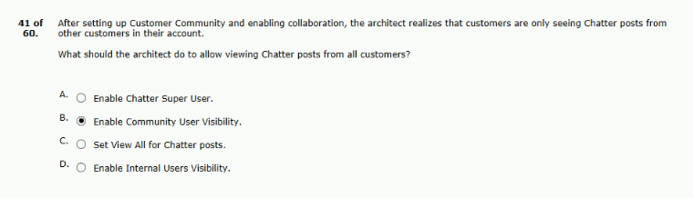
42.is not shown on the list of available fields.
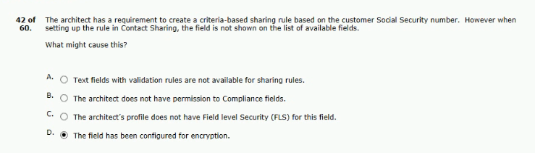
43.enable for large -scale role hierarchy realignments?
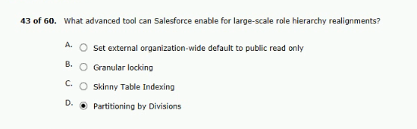
ANS:B
44.not have access to the file after the meeting.
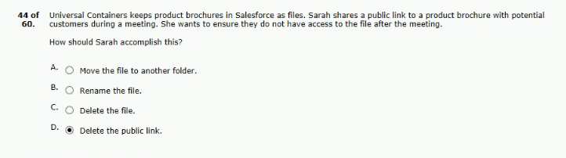
45.to ensure this cannot happen in the future.
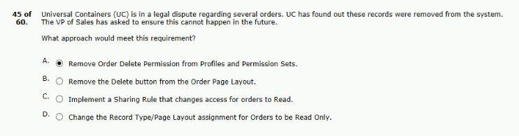
46.based sharing rules were created for each team.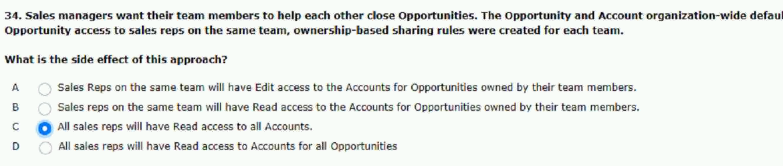
47.opportunities assigned to their distributor for delivery.
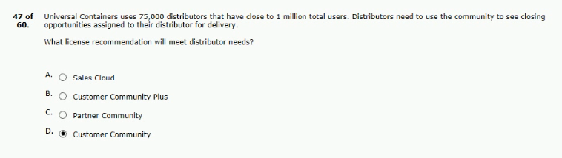
48.are complaining about two important points:
but sales reps are able to view it.
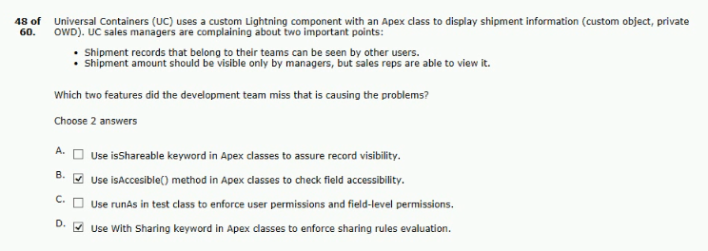
49.page layout has not changed with this deployment. 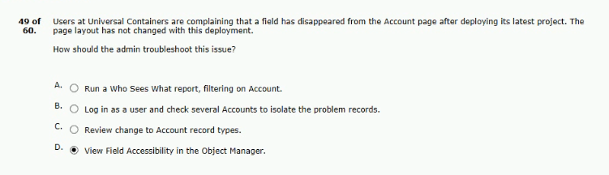

50.user visibility feature in its customer community.
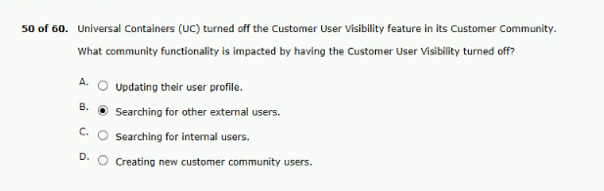
51.certain users profiles are being updated by this class.
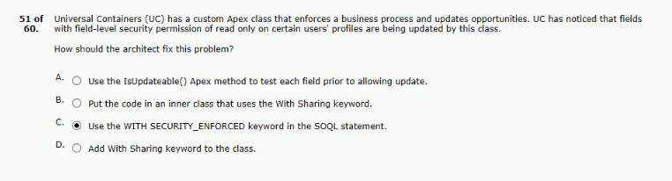
52.team is worried about improper access to records.
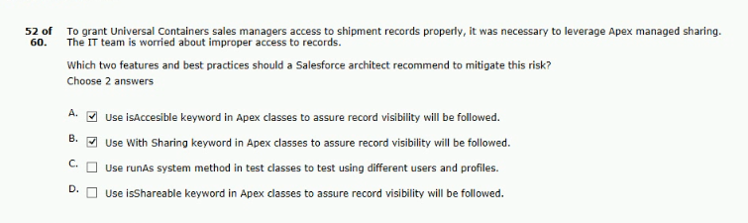

53.should have access to edit items in these folders.
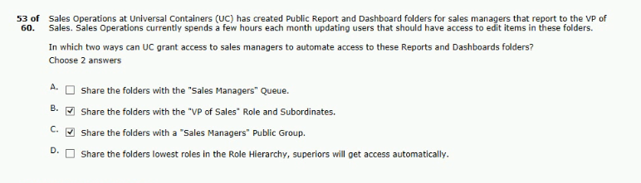
54.do not lose access to it when its owner is changed?
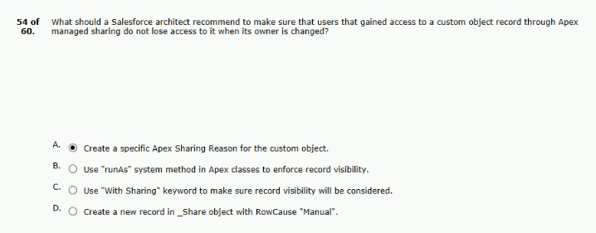
55.user is created on a partner account?
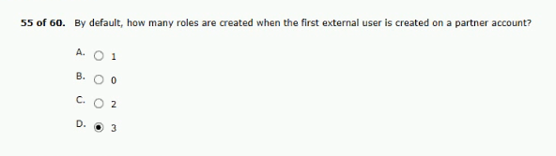

56.to data for certain individuals at a distributor.
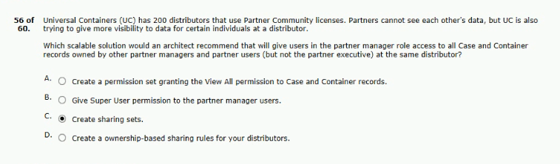
57.a new role was generated for every new user.
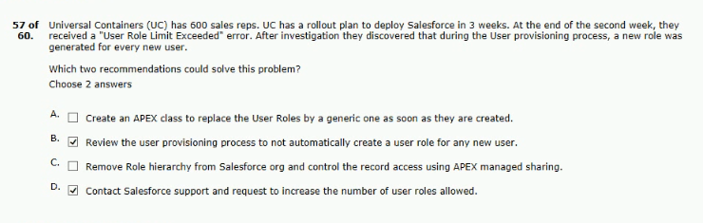
58.pilot a new application to a small set of sales reps.
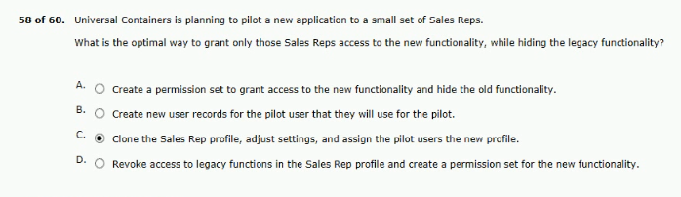

59.access to the invoice record in the account page.
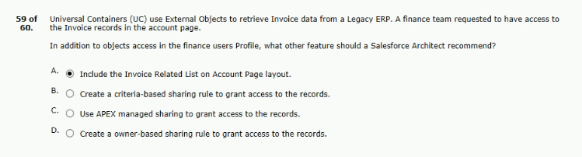
60.the delegated administrator permission provide?
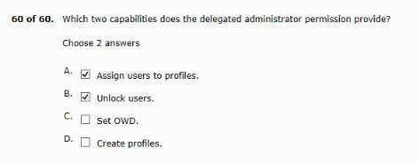
and be able to create opportunities for its customers.
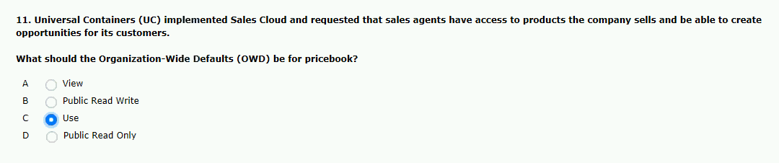
sharing rule to opportunities opportunity OWD is private.
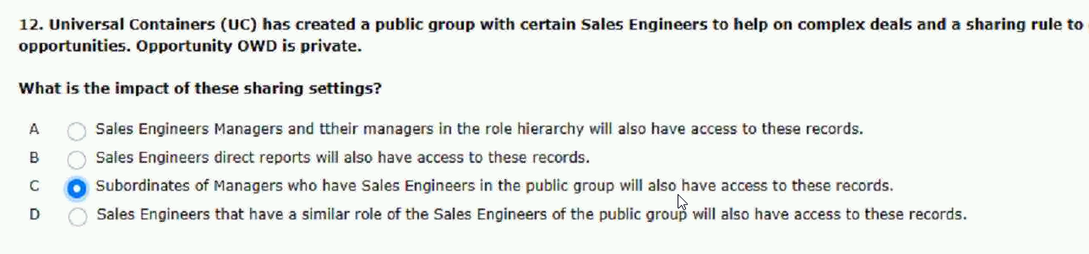

to the following business requirements:
with a recordType of prospect.
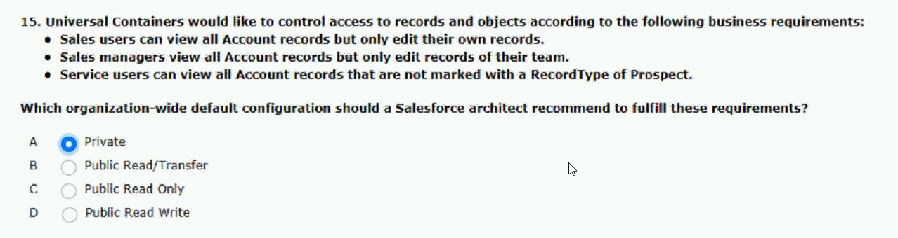
in the UC community.
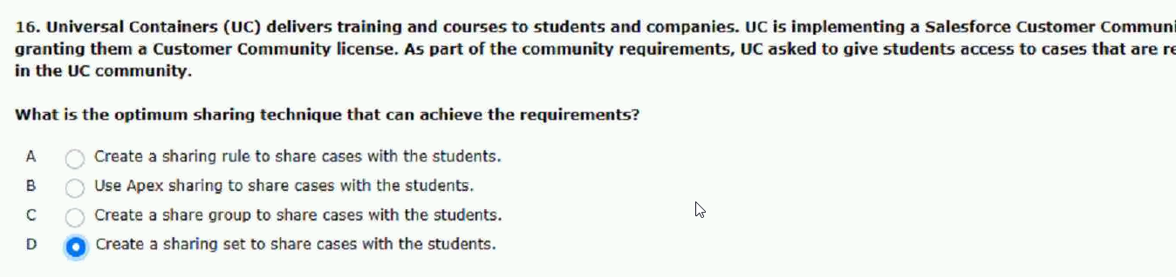
see feedback from other partner users.
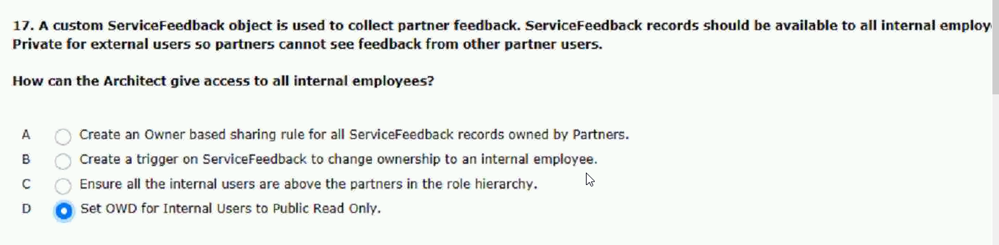

with many more data fields.
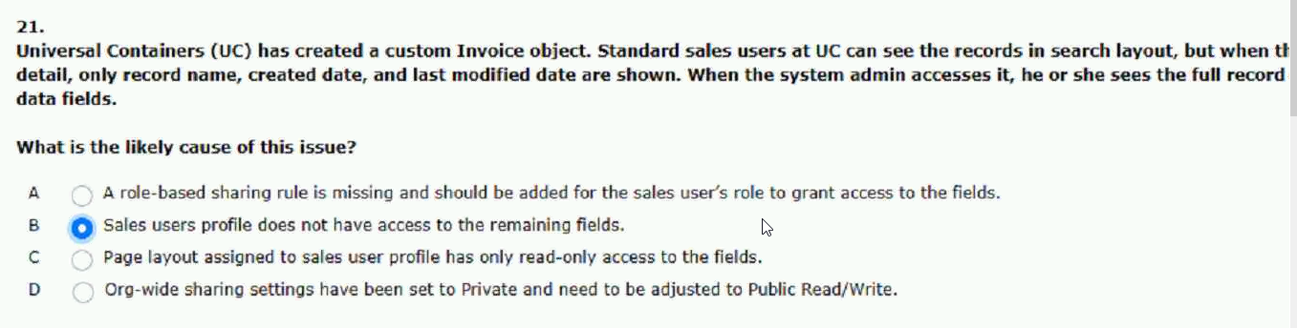
profile is not granted the invoice objects.
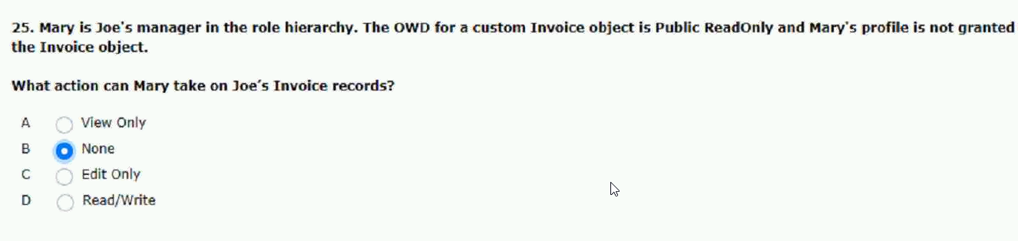
records the user is authorized to see.
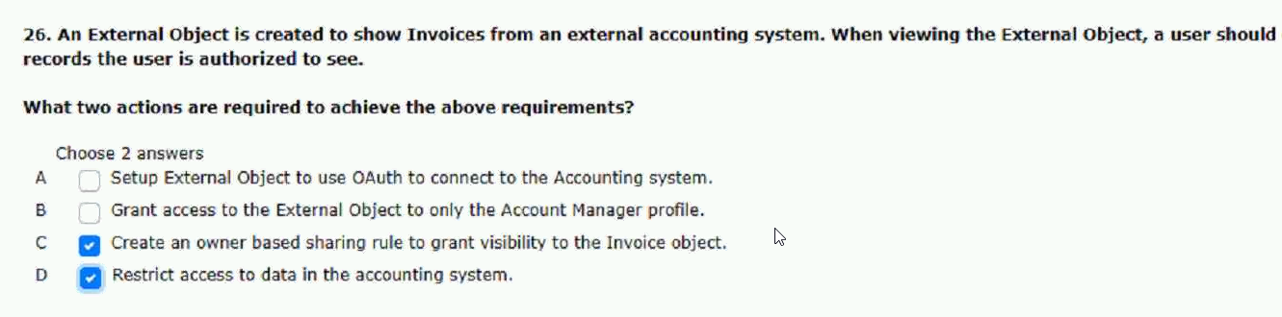
setting of public read only.
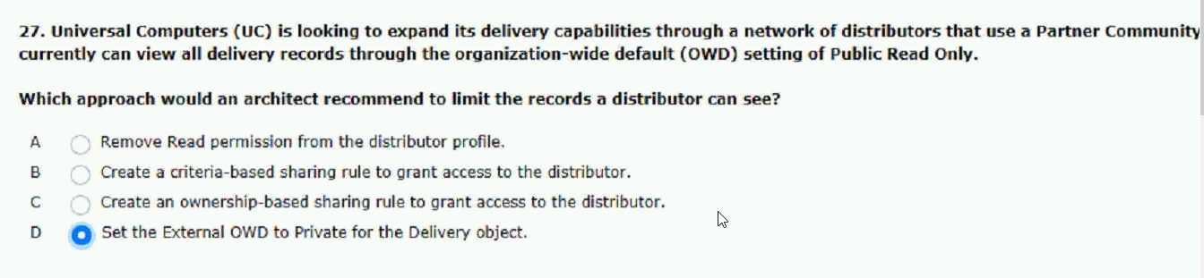

community sharing model is private.
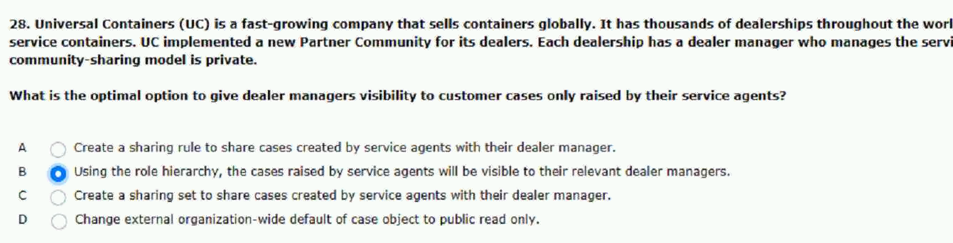
the case and the marketing consultants.
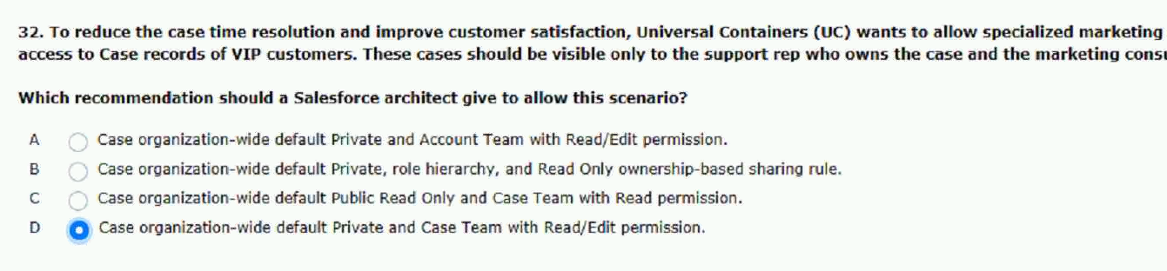
that all needs access to high-value opportunities.
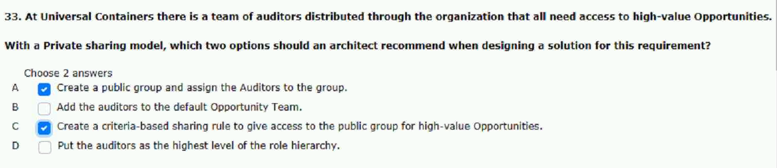
access to other distributor accounts as well.
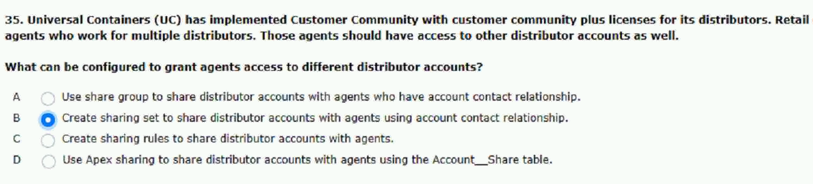

users can only see cases they created.
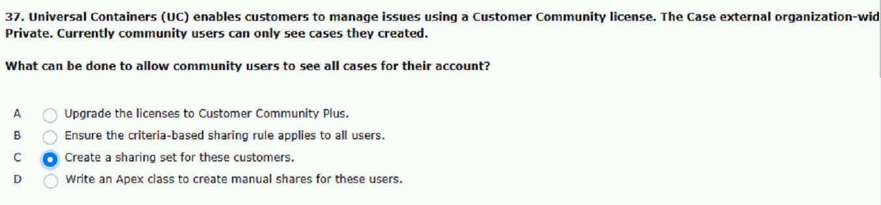
users is correct.
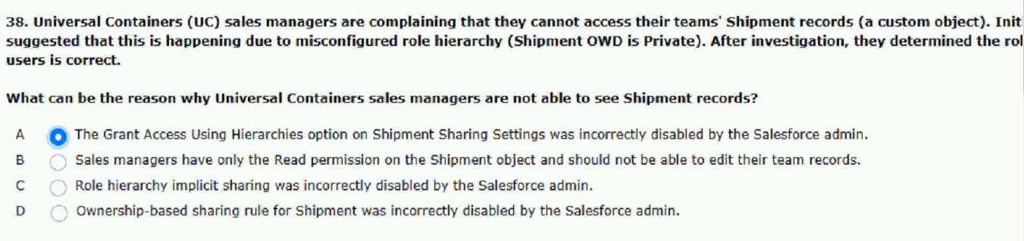
apex managed sharing to meet these requirements.
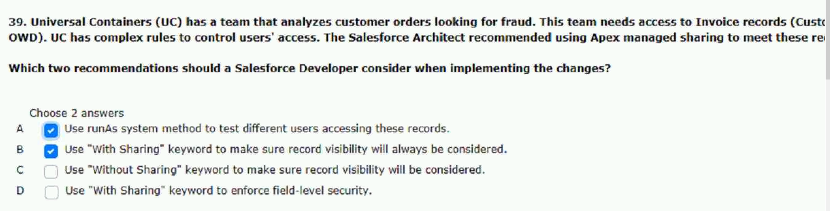
default for the container and case objects.
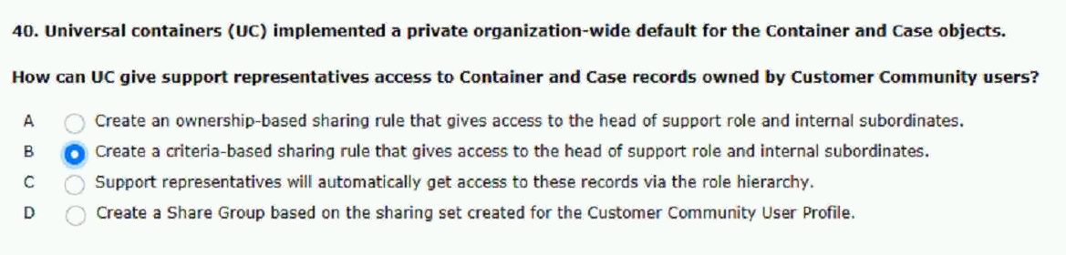

two weeks after the new fiscal year starts.
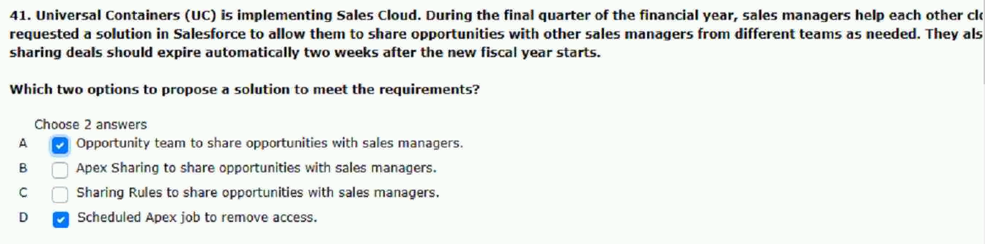
owned were transferred to a new sales rep.
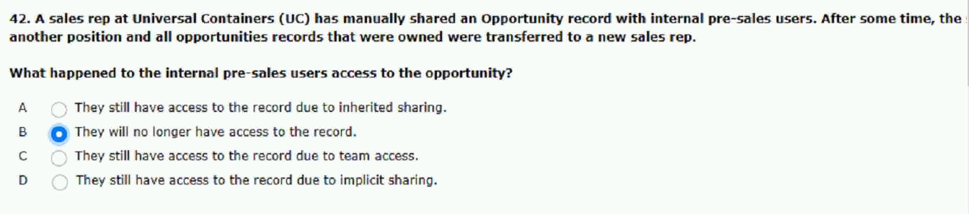
controlled by parent in sharing settings?
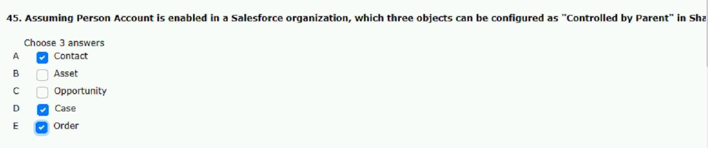
employees are required to collaborate on requests.
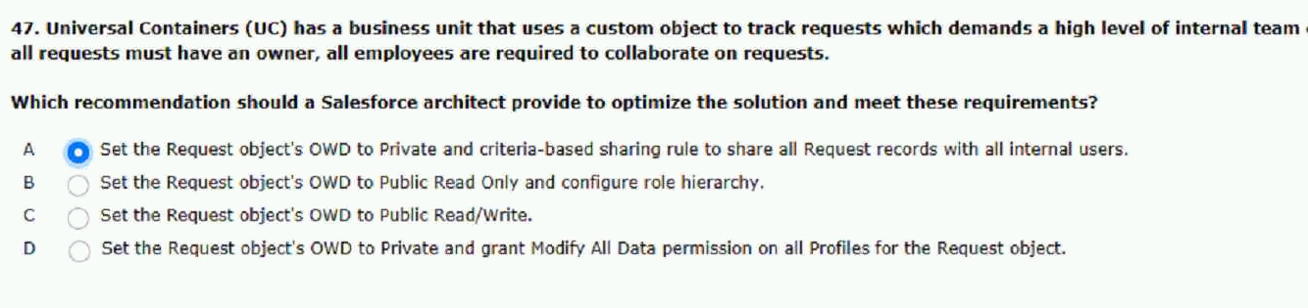

reps involved in the deals will not change.
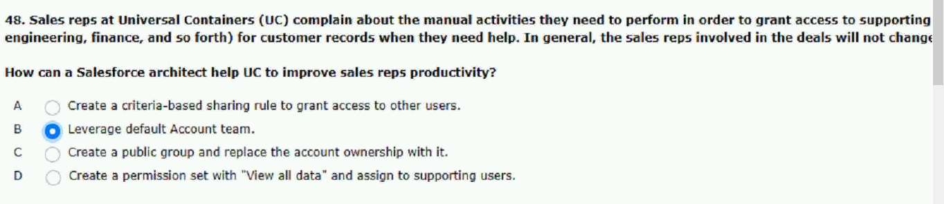
data with when creating a sharing rule?
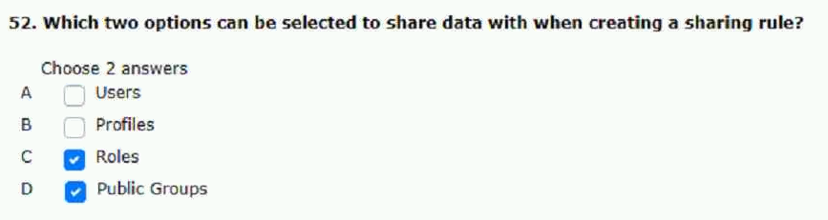
change opportunity data for all opportunities.
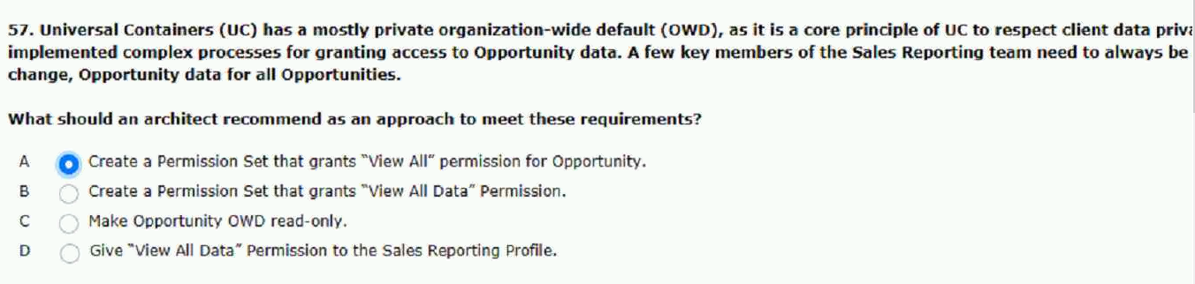
account object and needs to control the access.
can modify an account.
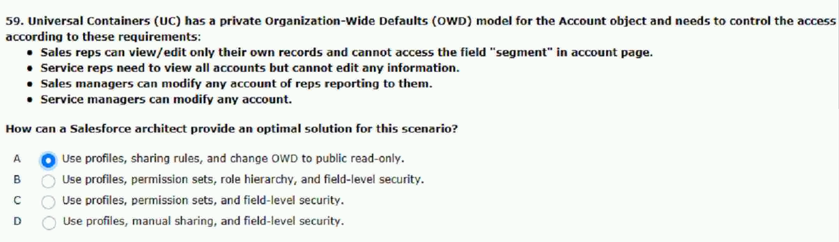
solar is writing test methods.
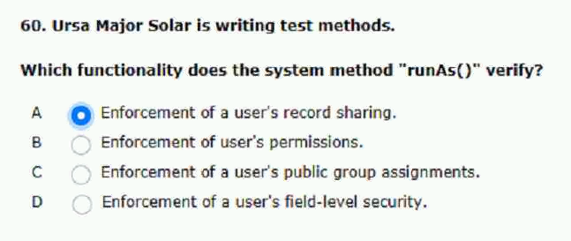
shared the record with john.
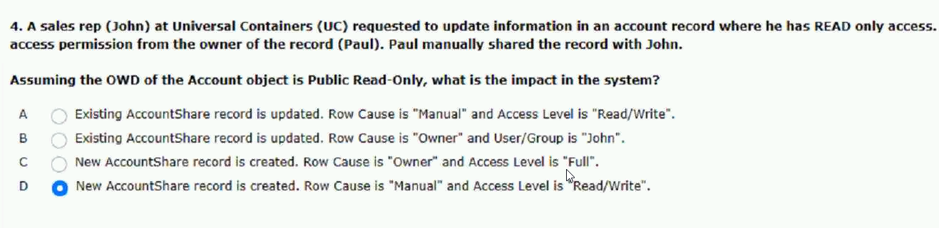
owned by the operation users team.
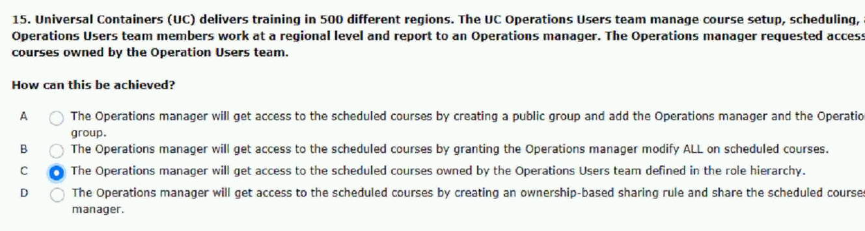

risk products can high risk products.
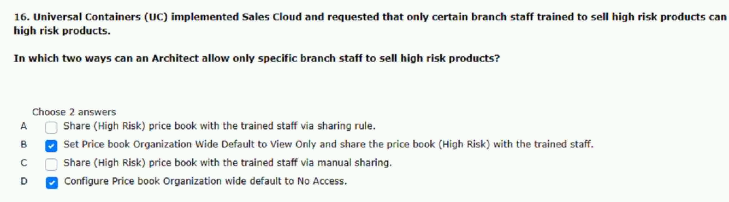
they determined the users is correct.
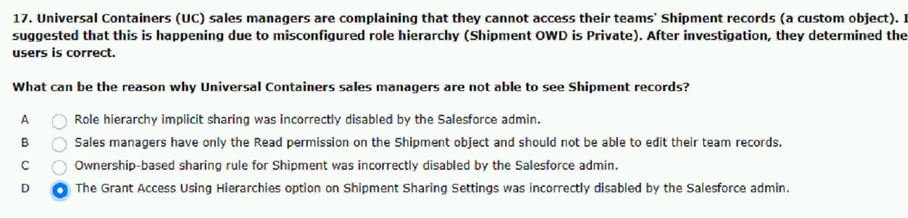
during their local working hours.
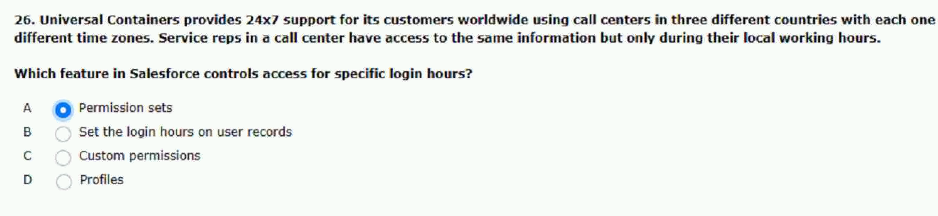
only the information that is allowed.
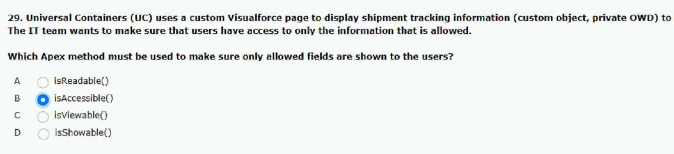

control according to these requirements.
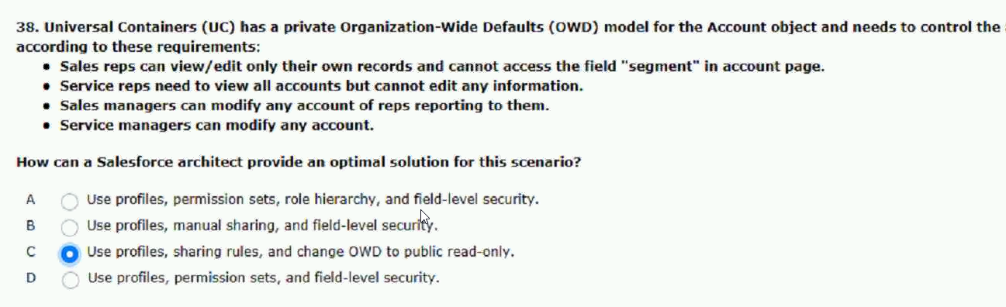
that were shared with the public group.
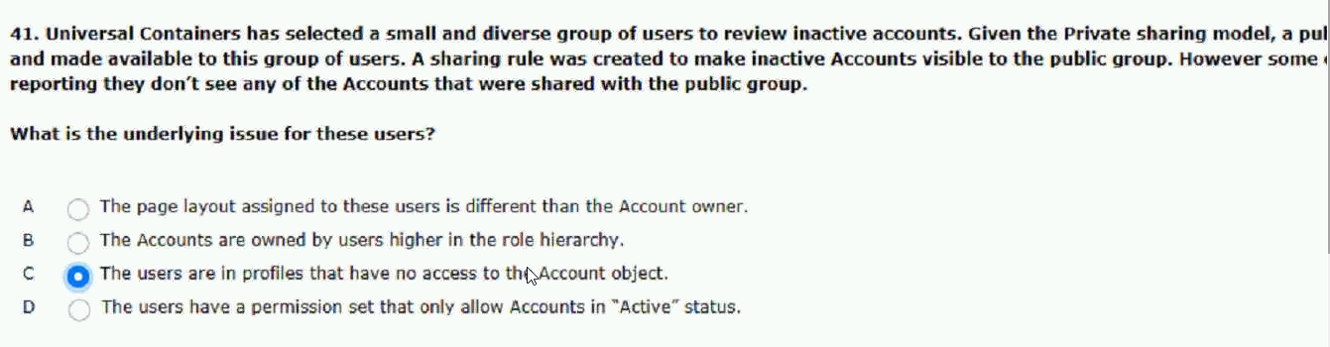
report in the private report folder.
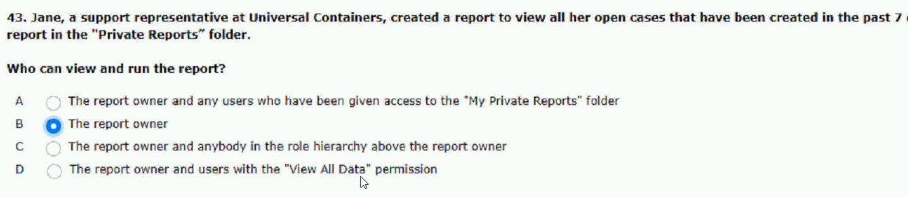
data with creating a sharing rule.
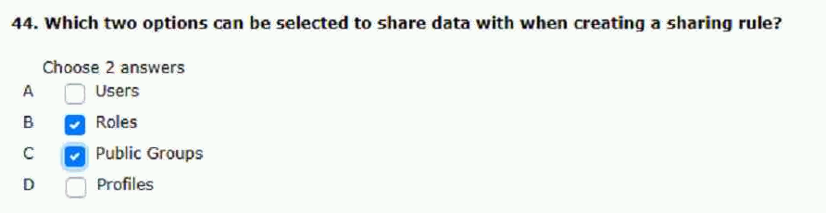

that specialize in closing problematic deals.
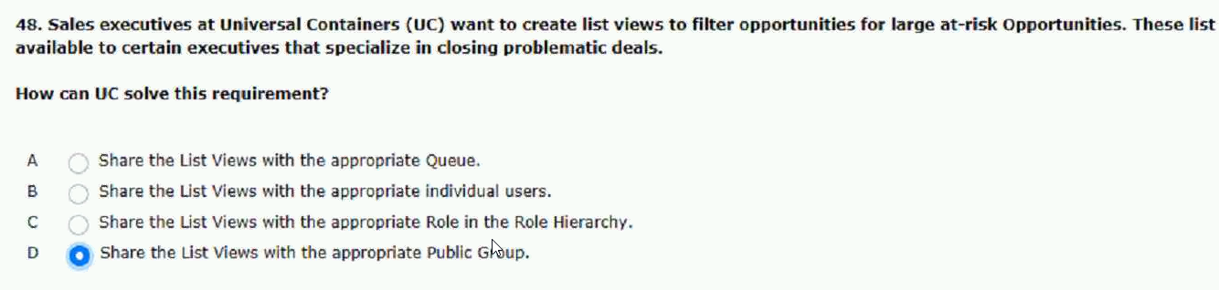
files home private library.
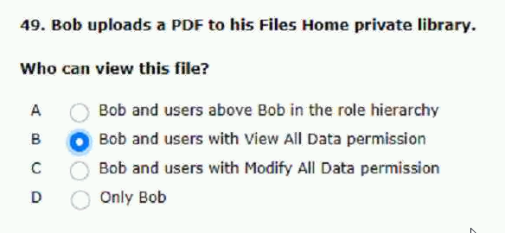
the read permission for the invoice object
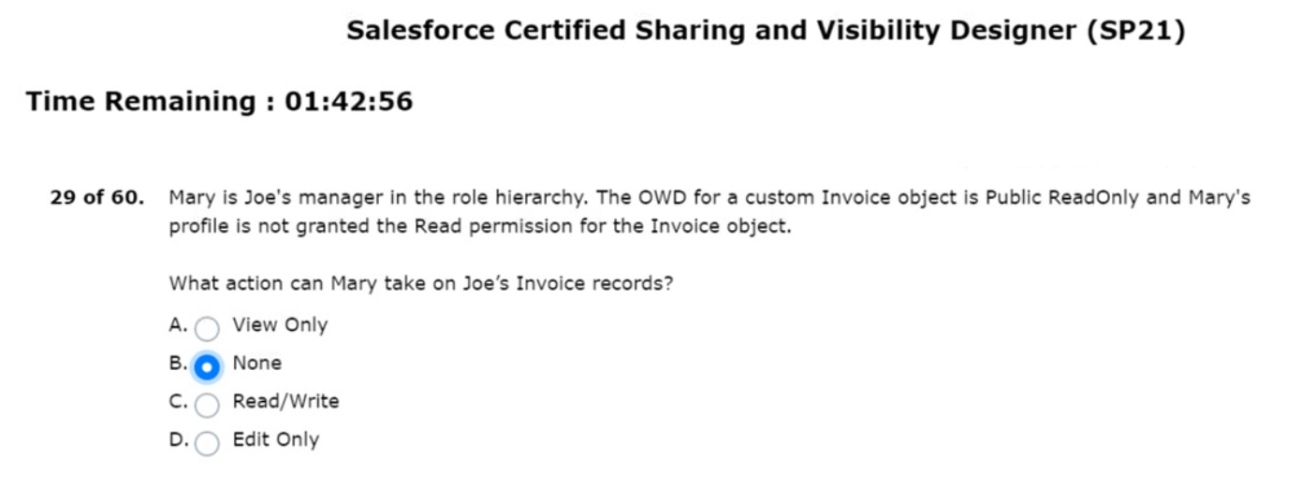

fields accessible to the human resource team
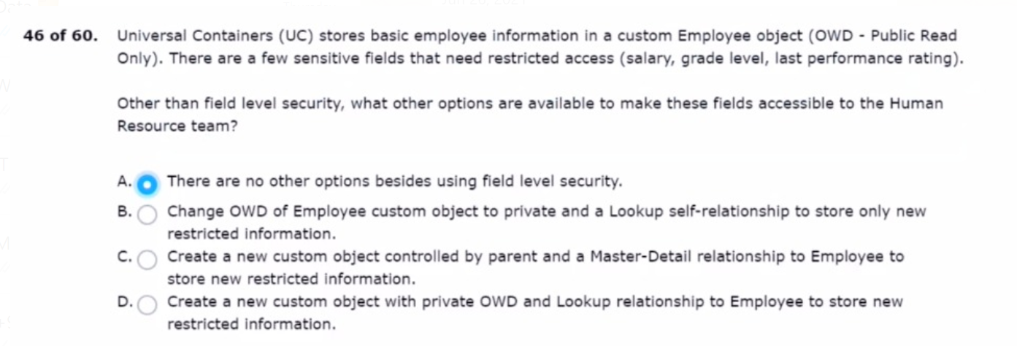
but the CISO has requested that any file links shared must be password-protected.
